


Dear parent/carers
In Somerset we know our young people have many skills and talents to offer employers. We know many of our young people can and want to work. However, we also know people with a learning disability are far less likely to have a job than the general population.
- 6% of adults with a learning disability known to their local authority in England are in paid work
- 17% of all adults with a learning disability in England are in paid work
- 52% of people aged 16 to 64 with any type of disability in Great Britain are in paid work
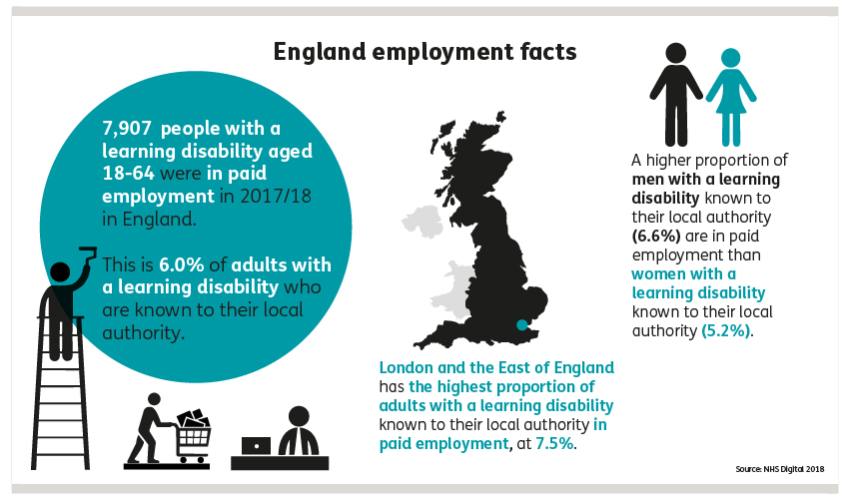
- 76% of people aged 16 to 64 in the general population in England are in paid work

To raise aspirations and realise potential we want to give our young people the opportunity to explore the working world. In order to achieve the best possible employment outcomes, we are asking you, parents/carers and other family members to consider offering experiences of work to our young people aged 15-25 in Somerset.
To help us, help our young people, please have a look at the list below and indicate where you may be able to help.
Give details
A tour or visit to your workplace
Work experience sessions
A visit to the school/setting to meet students
Practical demonstrations
Project work
A virtual session
Potential job opportunities E.g. supported employment

Please return this letter to school and we will be in contact to discuss this with you further. If you would like more information, please contact Shaun France Assistant Headteacher.
Thank you

