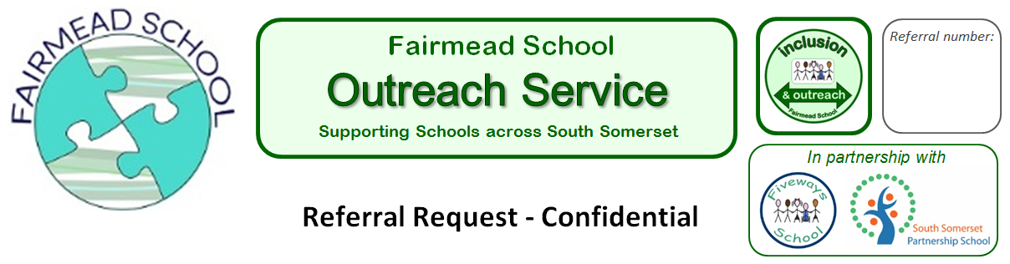

PUPIL information |  |  |  |  |  | SCHOOL information
Name of pupil: |  |  |  |  |  | Name of school / academy:
Date of birth: |  |  | NC Year: |  |  | Telephone number:
Does the pupil have an EHCP?  * If yes, please attach a copy |  |  | *yes / no |  |  | Name of headteacher / principal:
Does the pupil have an EHA?  * If yes, please attach a copy |  |  | *yes / no |  |  | Name of teacher:
Are there any current or historical  safeguarding concerns we need to be aware of?  *We may require further information |  |  | *yes / no |  |  | Name of SENCO:
Has the pupil ever received support from  Fiveways School? |  |  | yes / no |  |  | Name of person making this referral:
Has the pupil ever received support from  South Somerset Partnership School? |  |  | yes / no |  |  | Please tick this box to confirm that mandatory parental/carer consent for this .referral has been obtained by the school.
Other support agencies involved with this pupil:

Description of attendance:
Out of 10, how confident does your school feel in meeting this pupil’s needs?
1= lowest score / 10 = top score
National Curriculum Progress – compared against the expected level of attainment for his/her age (please tick):

Description | Speaking and Listening |  |  | Reading |  |  |  | Writing |  | Mathematics
Below the expected level
Towards the expected level
Within the expected level
Beyond the expected level

Identified needs and / or
additional difficulties:
Current provision in place:
Area of concern:
How do you feel the Outreach Team could best support this referral?

Additional information / comments: |  |  | DATE of referral:
PLEASE RETURN TO | Fairmead School, Mudford Road, Yeovil 01935 421295  outreachsch617@educ.somerset.gov.uk
Data Sharing (GDPR) | Personal data provided will only be disclosed to outreach team members supporting the pupil. Please contact us if you have any enquiries regarding personal data held by Fairmead School Outreach Service.
For use of Fairmead staff:
Date: | Communication type | Action / notes

